FUNCTIONAL DOCUMENTATION DRAFT

Preface
The project involves the implementation of an interaction system through which a singer can use hand gestures to activate real-time effects on their voice during recording.
The goal is to allow even users without specific music production skills to express preferences regarding how their voice should be modulated at certain points in the track.
Before proceeding with the definition of a development strategy, we carefully analyzed several scientific papers focusing on the topic of "hand gestures" in the context of music production. Unlike approaches found in the literature, which rely on devices such as Kinect cameras or infrared sensors (often applied solely to the control of musical instruments), The innovative contribution of this project consists in using the PC's integrated camera as a visual input, without the need for external sensing devices, for landmark extraction and hand tracking.
We will then move on to the conversion phase of the detected gestures into MIDI signals, which are then sent to an audio engine responsible for modulating the sound effects.
Finally, as a type of feedback, we considered an auditory response more appropriate, since, in this context, the user's perception of change is closely linked to the variation in their voice.

What about related works in the literature?
placeholder

Feature of this idea
We want to achieve a multi-dimensional interaction system, since we are involving both singer’s hands, so that we can subdivide actions into two dimensions, encouraging a more natural and consistent interaction too.

Architecture
Work pipeline
The implementation solution is based on the following workflow:
Python + MediaPipe + OpenCV + OSC/MIDI + DAW
Where:
- MediaPipe → for hand tracking / gesture recognition;
- OpenCV → for video management, preprocessing and camera feed visualization;
- A library for sending commands → MIDI (Musical Instrument Digital Interface);
- DAW (Digital Audio Workstation) → to manipulate the effects modulation parameters. In our case, we use Logic Pro X as audio environment.

Gesture design
The gesture design was defined to meet the following requirements:
- distinguishability;
- memorability;
- ease of execution during singing;
- reduced fatigue;
- low probability of accidental activation;
- semantic consistency with the controlled effect.
Furthermore, preliminary interviews were conducted with potential singers – or at least people familiar with this field – with the initial goal of presenting and discussing the design concept, then gathering feedback on the proposed gestures and evaluating any suggestions or alternatives.
The final gesture design was therefore derived from a combination of the requirements reported above and the observations that emerged during these preliminary interviews.

Types of gestures
- Left hand → effect selection
  - The user starts from the fist and the number of fingers he lifts determine the effect he wants to activate (e.g. lifting the first and second fingers => activating effect 2)
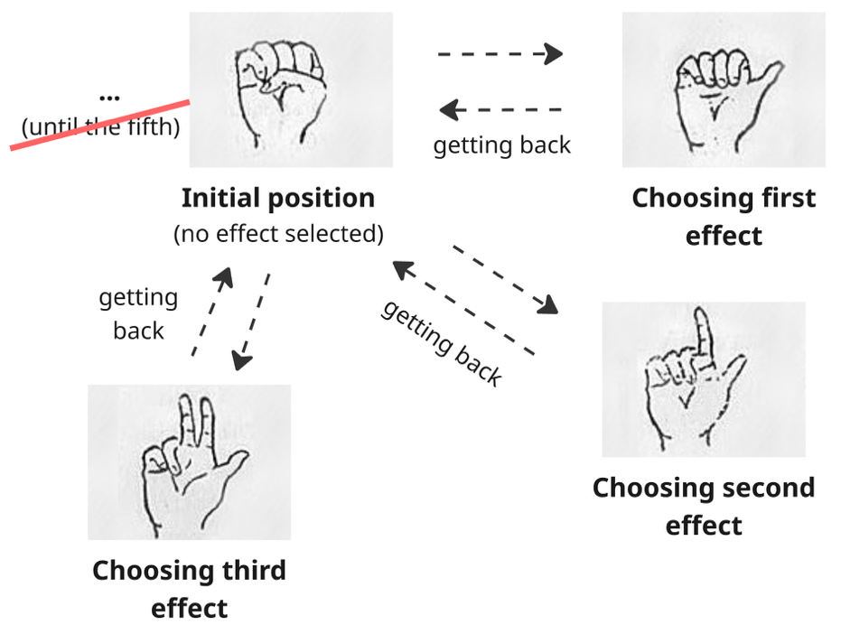
The constraint is that to switch from one effect to another one, the user must always pass from the initial position (becoming a transition point). Moreover, this position can be used to lock the amount of the selected effect once the desired point is reached.

- Right hand → modulation of the effect selected through two modalities (not handled simultaneously).

Modality 1 — pinch distance
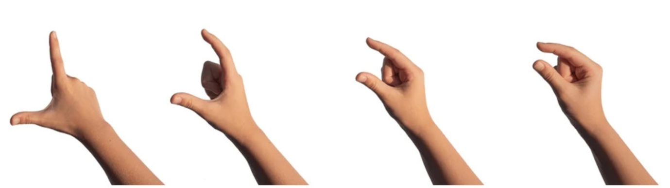
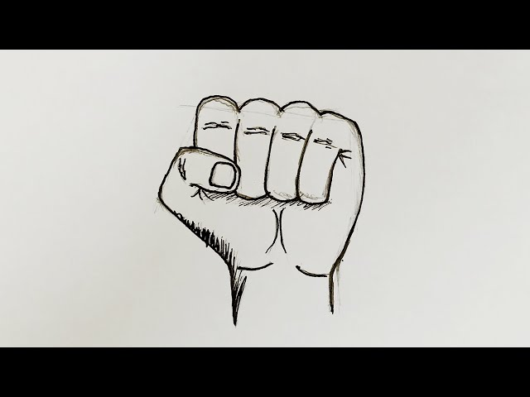
To turn off all effects at once

Modality 2 — hand openness
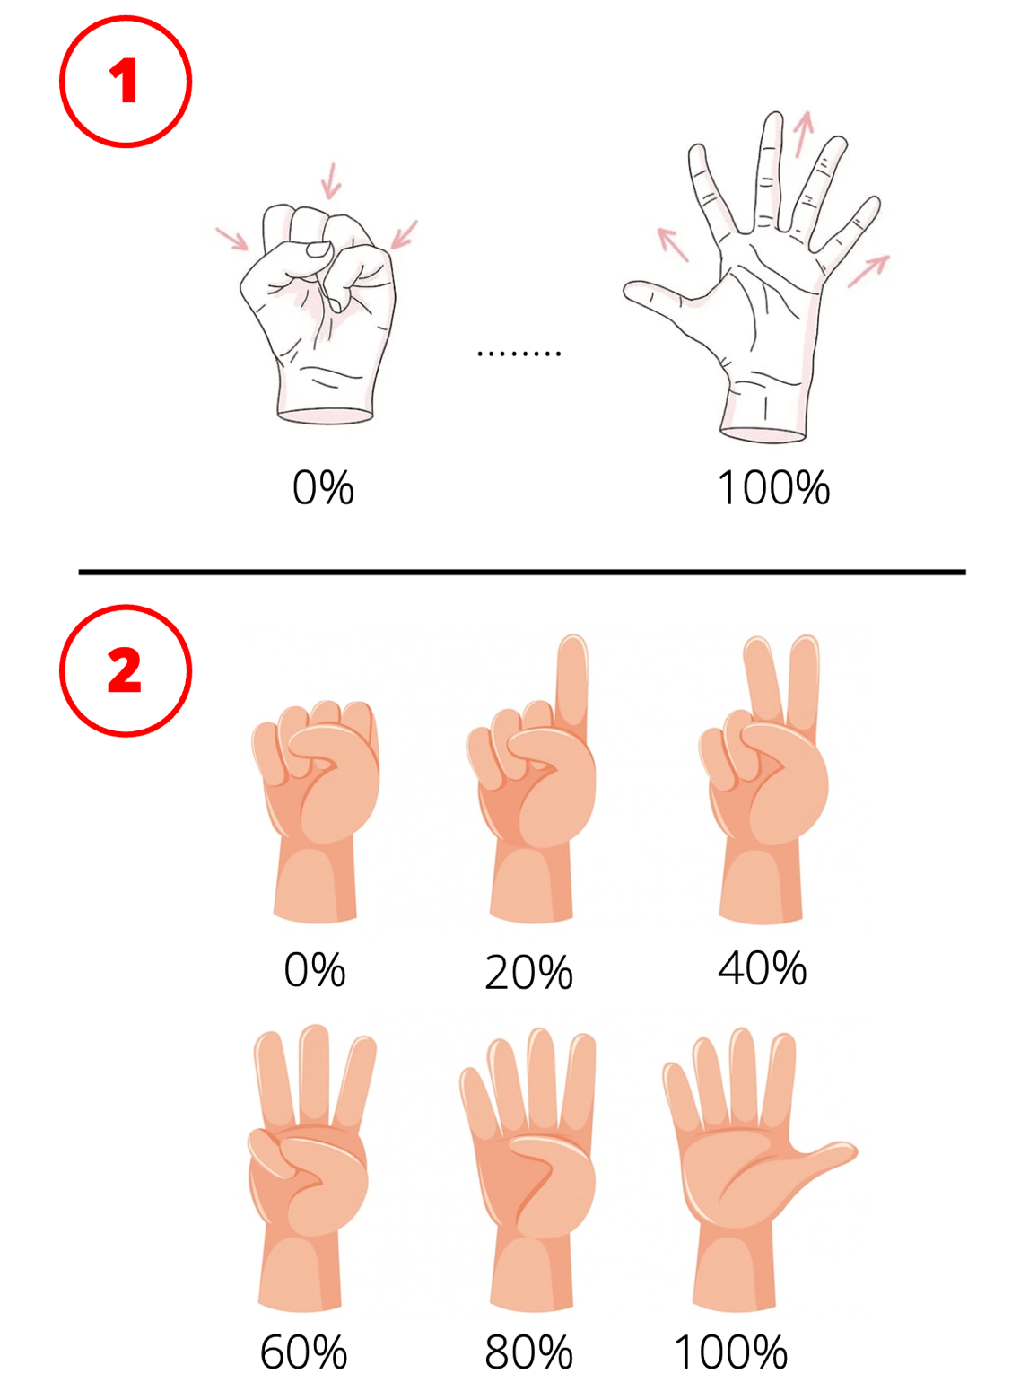

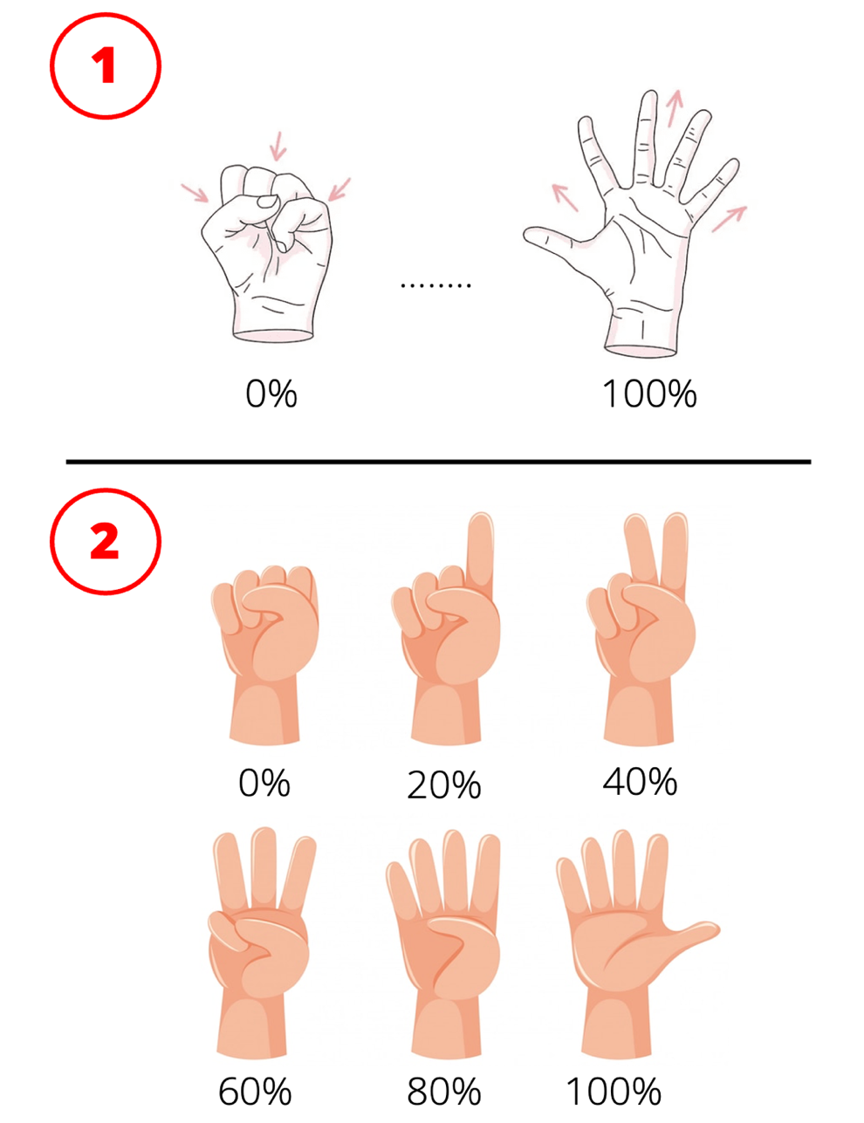
Hold this position to turn off all effects at once

Modality 3 — vertical directional gesture (PROBABLY DISCARDED)
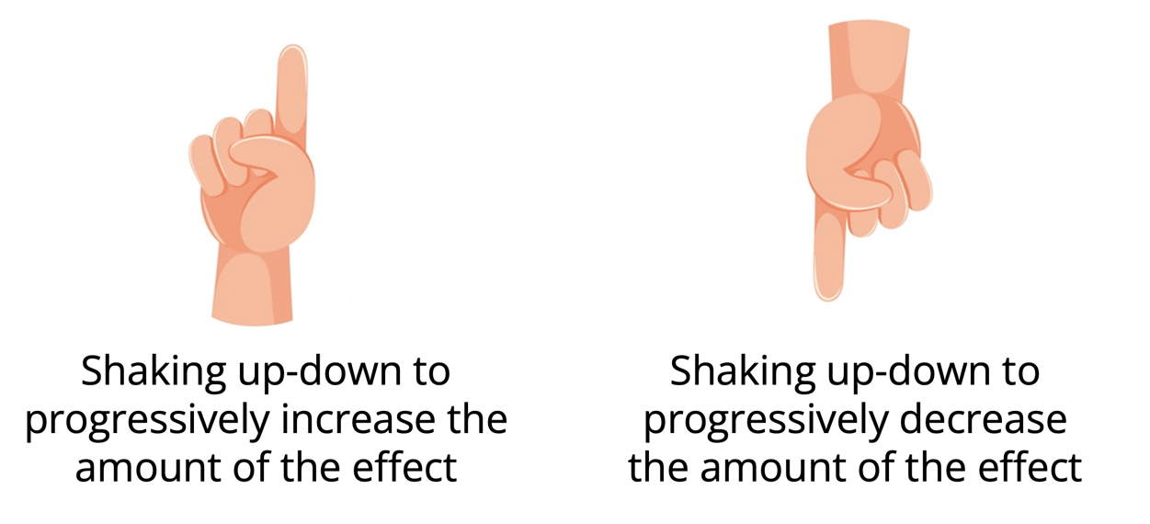
PLEASE DISREGARD

We want to implement and compare these right-hand modulation strategies with the aim of evaluating which interaction style provides the best balance between accuracy, comfort, responsiveness, and perceived control in a vocal performance scenario.

Evaluation metrics of this idea
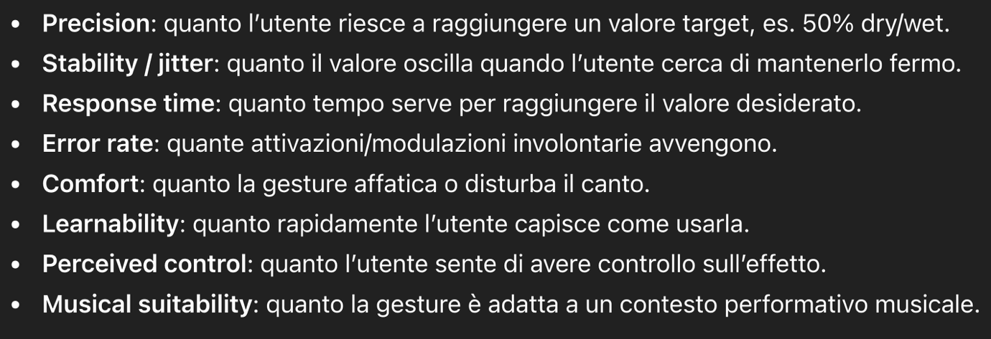

Feasibility
The overall gesture-based interaction is feasible using real-time hand tracking, but each modality differs in terms of stability, control precision, and sensitivity to noise, requiring specific design and filtering strategies.

Challenging points
What we need to take most care of is the precision of tracking and the stability of movements, especially for movements performed rapidly. So, we can consider to apply some “filters” to reduce jitter and unintended variations in continuous gesture input, improving control precision and perceived responsiveness.
The system reacts only when it receives a signal that is stable enough over time.

What about the audio engine (Logic Pro X)
We used MIDI Control Change (CC) messages, that are a type of MIDI data used to transmit continuous control information, allowing real-time modulation of parameters such as volume, effects intensity, or other audio processing settings. More specifically:
- CC number = which parameter we want to control
- CC value = the intensity of the parameter we want to control
In our solution, we have included a library called “mido” that is responsible to handle MIDI data and messages. Then we mapped up the right-hand pinch gesture into a continuous value (0–127) messages. These messages are sent in real time to Logic Pro via a virtual MIDI port (IAC Driver), where they are mapped to effect parameters (e.g., wet/dry), enabling dynamic and contactless modulation of audio processing during performance.

